Topic Area: | Early Childhood -
Source: | Early Childhood Longitudinal Study, Kindergarten Class of 1998-99
Year of Data: | 2000
Percent of first-graders scoring in the top 25 percent in reading, the percentage who, at kindergarten entry, can recognize the letters of the alphabet, who are read to at least three times a week by a family member, who are proficient in numbers and shapes, and who are proficient in relative size: Spring 2000
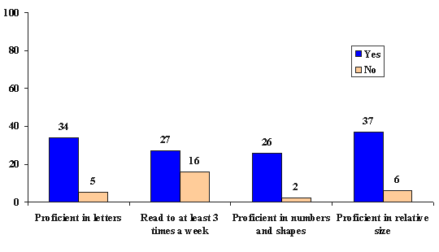
NOTE: Estimates reflect children assessed in English in all three rounds of data collection and who entered kindergarten for the first time in the fall of 1998 and were promoted to first grade in the fall of 1999.

